Progress Blogs (10/09/17)

For this assignment, you should make regular, **individual** blog posts on the two parts of this assignment: the *scientific and technical* portion, and the *teamwork and project management* portion.

**scientific and technical**

My task was to complete the three functions in mandelbort.c, last night I completed the escapeSteps function. To approach this function, the first thing I did was understanding how the steps was calculated by using complex number. From the given equation

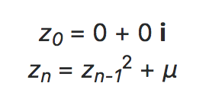

I found that in this function, the given complex number c was a constant like u in the equation, I treated first value of z was 0 + 0i and calculate the absolute value of z, if abs value of z not greater than 2, the next z value equal to the square of last z value plus the given complex number c, and then escape steps became 1. The whole process stop until the abs value of z not smaller than 2 or escape steps reach the MAX_STEPS. This process could be write as a ‘while’ loop.

I made serval functions to calculate the sum, square and absolute value of complex number and call them in the while loop and I complete the escapeStpes function smoothly. But I haven’t test it yet, I will try to test it by put it into a main function and make some unit test.

**teamwork and project management**

For the task I need to do, everything goes well, I have completed about 1 functions out of 3. The next step I want to do was to complete function escapeGrid, if possible, I will also make drawMandelbort done. I believe my partner also have complete some part of the server. So up to now, everything goes well.

Progress Blogs (11/09/17)

For this assignment, you should make regular, **individual** blog posts on the two parts of this assignment: the *scientific and technical* portion, and the *teamwork and project management* portion.

**scientific and technical** portion should discuss the progress you make in developing your solution, technical aspects of your server’s design, the bugs you’ve encountered, how you fixed them, and discoveries you’ve made in the Mandelbrot set.

Today I completed functions escapeGrid and drawMandelbrot (first set the color in pixelColor function). At the beginning, I was confused what the given complex centre and zoom level use for. To figure out it, I reread the assignment requirement and found that the zoom level was used to calculate the actual pixel length, pixel length depends on the zoom level (pixel length = 2^-z). For the given complex centre, I found that we need to treat it as origin (0, 0). So, we need to use both z and centre to determine the actual coordinate (represented by complex number, x + yi) of each pixel and determine how many steps each pixel took to escape the Mandelbrot set.

Add function here.

Because we haven’t successfully build the server, I can only test this function use small size array (60x60) in the terminal and found that inside the Mandelbrot tile, the steps each pixel took was all -1.

From the interesting thing found above, I set different colour determined by different steps (in pixelColor.c), if escape step was -1, pixel colour was back, else pixel colour was white (just first version).

Add function here

Then In drawMandelbrot function we use equation above to determine colour of each pixel, from this hopefully we can get a basis picture of Mandelbrot set.

Blogs on the **teamwork and project management** portion should discuss how well your plan is going, and what changes you’ve made to your plan. This may include how your division of work went,

From now on, I have completed all the functions in the Mandelbrot.c and pixelColor.c, and test it through terminal and it seems work. Because the server hasn’t been built, next step I want to test the colour of it by using the similar way of chessboard, hope it can print a Mandelbrot tile in bmp files. My partner was still on the way building the server, after I make sure my Mandelbrot function work I will start work with him about the server.

Progress Blogs (12/09/17)

**scientific and technical** portion should discuss the progress you make in developing your solution, technical aspects of your server’s design, the bugs you’ve encountered, how you fixed them, and discoveries you’ve made in the Mandelbrot set.

I tried to draw Mandelbrot tile using the same way of drawing chessboard. I put all functions in one file and enter centre coordinate and zoom level. First I set all pixels which escape was -1 into black colour and else into white, the picture return looks that below. (version 1)

Add 1st picture

Then I tried to let the Mandelbrot have boundary, I set pixels which escape was -1 into grey colour, steps between roughly 15 to 256 (steps > 15 && steps < MAX_STEPS) into black and else into white, the picture have boundary now but not quite clear. (version 2)

Add 2ed picture

I also found that probably something wrong happen to my escapeGrid function, because when I entered a centre coordinate and zoom level, the returned picture was not same as what I want, but the other functions should be fine.

I found that if the colour was not just being set by hand one by one, there exits some functions between pixel colour and steps which can make the colour amazing. I searched online and found some related equation, then I write an equation and print out a picture like below, it seemed better than before but still not the colour what I want.

Now I’m still not clearly know the relationship between colour value (rgb) and escapeSteps. Next step I will figure out it and find out the bugs in my escapeGrid function.

Blogs on the **teamwork and project management** portion should discuss how well your plan is going, and what changes you’ve made to your plan. This may include how your division of work went,

Now what I need to do is continue learning the relationship between colour value and escapeSteps and keep testing it through printing bmp files.

After my partner finish the server we can combine them together and test it through the server.

Progress Blogs (13/09/17)

**scientific and technical**

Today, I focused on creating colour for Mandelbrot set, my partner worked for building server. We have successfully build the server which able to explore our Mandelbrot tile and create a 512 x 512 pixels’ output image by entering zoom level and coordinate. But the server was very unstable and it always disconnected automatically, there must exist some bugs and our next step is to find and fix them.

To test the equation in mandelbort.c files was correct, I entered z = 8, x = -1.0, y = 0.5 and the returned image was the same as I expected which means the equations was all correct.

Enter image

I also tried several sets of RGB colour to discovery how the intensity change of red, blue, and green will affect the colour output of Mandelbrot. (use equation below)

Enter equation

**teamwork and project management**

At first I thought this assignment was tough and need to spend lots of time. After I start it I found that it was interesting and not that hard as I thought. Maybe we can complete it in advanced of our planning finish time.

The next step for me is to discover a more amazing colour of Mandelbrot tile (my last task) and fix the bugs of server (both me and my partner). Then we will test and debug the program and make a conclusion, also write final reflection.

**Coordinate and zoom level**

mandelbrot/2/22/0.2579/0.0011/tile.bmp

z=19,

x=-0.7448948522167,

y=0.11569717120330869

zoom：37

x：0.34669124953506986

y：0.08194073246567889

zoom: 16

x:-0.7448944095522167

y:0.11569717120330869

x:0.39242435741289047

y:-0.04200602025769028

zoom: 19

x: -0.747189

y: 0.079685

X:-1.1199 Y: 0.219 Z: 15

mandelbrot/2/26/0.2547705620527268/-0.0005319863557677147/tile.bmp

<http://almondbread.cse.unsw.edu.au/mandelbrot/2/20/-0.06772041320800783/0.6659444869618056/tile.bmp>

<http://almondbread.cse.unsw.edu.au/mandelbrot/2/35/-0.7492023799568415/0.05088839360962783/tile.bmp>

<http://almondbread.cse.unsw.edu.au/mandelbrot/2/20/-0.7495228848876955/0.047934522110760169/tile.bmp>

<http://almondbread.cse.unsw.edu.au/mandelbrot/2/24/0.262895/0.002784/tile.bmp>

**Zoom:**26

**X:**0.34575906395912176

**Y:**0.08420303430461992

0.2 -0.7

zoom = 21

x = 0.2642

y = -0.00274

自己找的点

<http://almondbread.cse.unsw.edu.au/mandelbrot/2/27/-0.7485413327813148/0.06507327993820095/tile.bmp>

<http://almondbread.cse.unsw.edu.au/mandelbrot/2/27/-0.7685668021440508/-0.10093477102552115/tile.bmp>

better one

<http://almondbread.cse.unsw.edu.au/mandelbrot/2/27/-0.7685668617486956/-0.10093504669615652/tile.bmp>



Progress Blogs (14/09/17)

For this assignment, you should make regular, **individual** blog posts on the two parts of this assignment: the *scientific and technical* portion, and the *teamwork and project management* portion.

**scientific and technical** portion should discuss the progress you make in developing your solution, technical aspects of your server’s design, the bugs you’ve encountered, how you fixed them, and discoveries you’ve made in the Mandelbrot set.

13-09-17

Successfully built the server, but it was very unstable and always disconnected automatically.

14-09-17

Modified server.c code following what Andrew post.

1, First change –y to y, as following (some people said the Mandelbrot images will upside-down, but I didn’t find this when I test it yesterday, maybe the time I test the server hasn’t broken)

Add code here

2, Secondly, to fix the issue where sometimes the server will crash automatically. I added following code after the start of main function in server.c.

Add code here

And add #include <signal.h> up the top with the other #includes.

After I add them, the server didn’t crash anymore, but the speed was still very slow when I tried to zoom or drag it. (fix it next step)

3, Fixing an issue with running Mandelbrot server on VLAB, sometimes it fail to bind to the socket but sometimes work.

Change from:

Add code

to

add code

Blogs on the **teamwork and project management** portion should discuss how well your plan is going, and what changes you’ve made to your plan. This may include how your division of work went,

* localhost:19976/mandelbrot/2/21/0.2695391178131104/0.004480123510873004/tile.bmp

color.red = fabs((sin(steps * 0.091) * MAX_STEPS));

color.green = fabs((sin(steps * 0.025) * MAX_STEPS));

color.blue = (steps * 5) % MAX_STEPS;

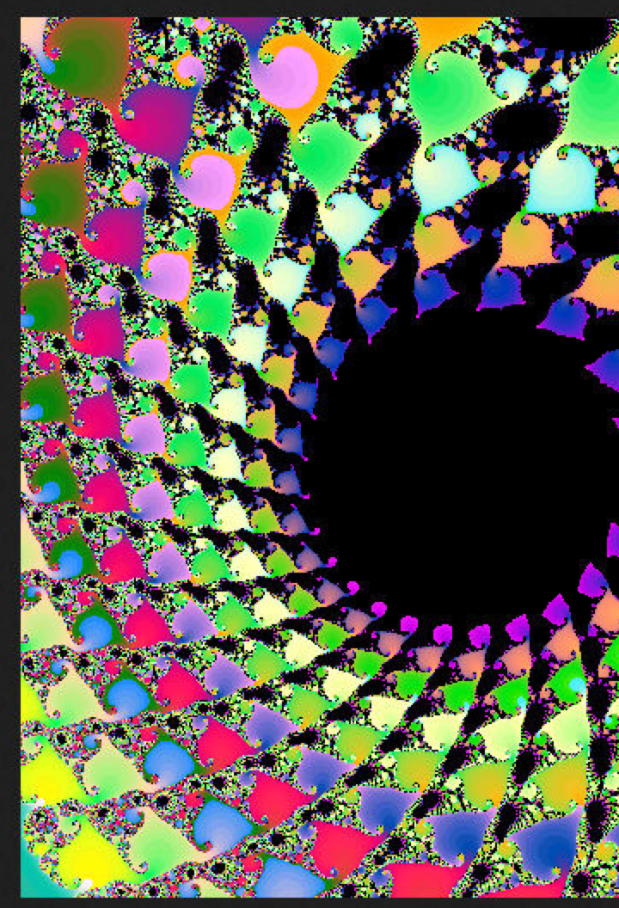

zuihouyici

color.red = (1 - steps / MAX_STEPS) * MAX_STEPS;

color.green = (fabs(sin(steps * 0.01))) * MAX_STEPS;

color.blue = (fabs(sin(steps * 0.05))) * MAX_STEPS;

}

<http://localhost:19970/mandelbrot/2/23/-1.3933780311465456/-0.008171439116055257/tile.bmp>

color.red = fabs((sin(steps * 0.05) * MAX_STEPS));

color.green = fabs((sin(steps * 500) * MAX_STEPS));

color.blue = fabs((sin(steps * 0.07) * MAX_STEPS));